Exercises Biol-480 – Neuroanatomy (13/09/2024)

General Questions
- Define the two main divisions of the nervous system and their components.
- In the diagram below, label the five major divisions of the brain (Telencephalon, Diencephalon, Mesencephalon, Metencephalon, Myelencephalon)

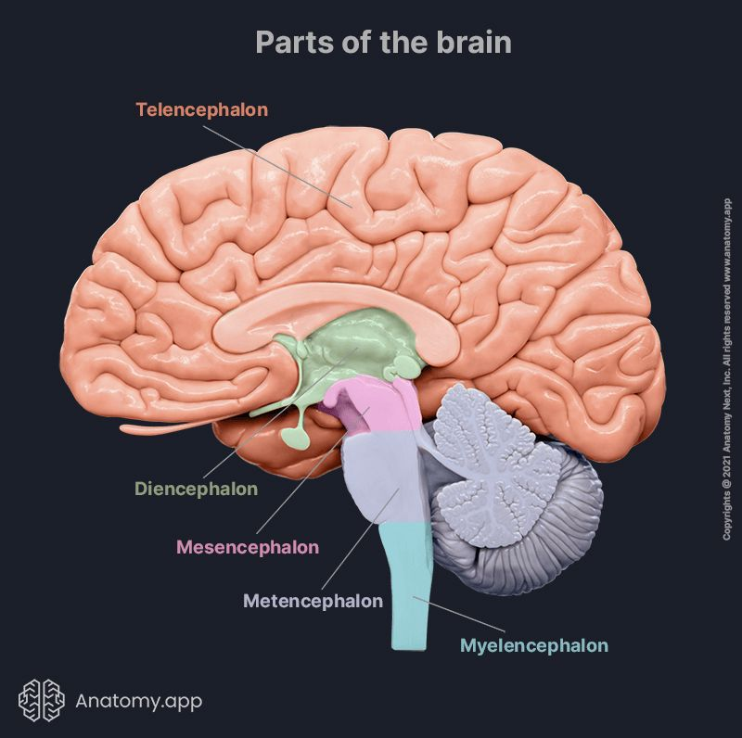
5: …
4: …
3: …
2: …
1: …

Case studies

Case 1

A 72-year-old man was admitted to the hospital because of progressive gait unsteadiness, memory difficulty, and incontinence. His gait unsteadiness developed over the course of about 1 year, beginning with a shuffling stride and difficulty rising from a chair. This unsteadiness progressed until he required a cane and, eventually assistance from another person in order to ambulate. Urinary incontinence began 4 months prior to admission, and his family noted the onset of memory problems at around the same time. Examination on admission was notable shuffling gait, the patient barely lifting his feet off the floor.
Examination: A head CT was performed (see Figure 1).
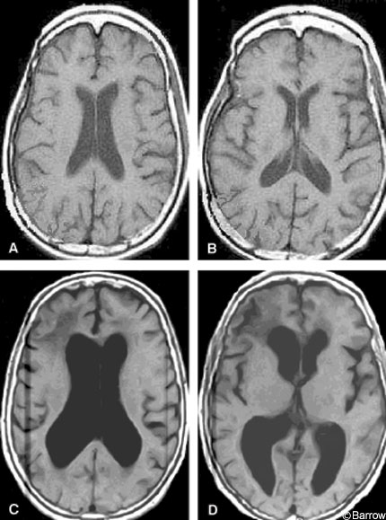
Figure 1: Comparison of CT scans of a healthy 75-year-old woman (A, B) and of the 72-year-old man admitted to the hospital (C, D). (© Dignity Health 2014)

- What type of section of the brain are you looking at? Coronal, sagittal or horizontal?
- What is the most striking feature of these images?
- What syndrome fits the clinical history, exam, and CT scan of the patient?

Case 2

A 45-year-old man was brought to the hospital after being found unconscious at the scene of a car accident. He regained consciousness briefly but remained disoriented and lethargic. His family reported that he had been drowsy and unresponsive over the past few days, with no recollection of recent events. On examination, the patient had irregular breathing and showed a lack of reflex response.

1. What part of the brain is most likely damaged, based on the symptoms?
2. Which system in the brain controls the state of wakefulness and consciousness that might be affected in this patient?

Case 3

A 28-year-old man has been experiencing auditory hallucinations, hearing voices that aren't there, and having delusions, such as believing that he is being followed by secret agents. He has also shown disorganized thinking and speech, often jumping between unrelated topics in conversations. His family noticed that his behavior has become increasingly erratic and withdrawn over the past year. A neurological examination and brain imaging revealed abnormal activity in certain brain regions, particularly in the midbrain and frontal cortex.

- Based on the symptoms presented above, what is the most likely diagnosis?
- Which brain structure in the midbrain is involved in the onset of these symptoms?
- What area of the brain is likely implicated in his auditory hallucinations, and why?

